Hi!
If you read this document so you bought my asset!
In this asset everything are simple. Code is easy and has summaries.

- Before building this game to your phone you need to download the latest version of Admob plugin for Unity from there and open asset in Unity 2021 and upper (because of it is a requirement for Admob plugin): https://github.com/googleads/googleads-mobile-unity/releases/tag/v6.1.2
- After downloading complete import GoogleMobileAds.unitypackage to project. And finish steps from guide here:
https://developers.google.com/admob/unity/start
- In the Unity editor click for Android:
Menu→Assets→External Dependency Manager→Android Resolver→Force Resolve.
For iOS:
Menu→Assets→External Dependency Manager→ iOS Resolver → Install Cocoapods
Then to show advertisement in your build you need to change advertisement id.

- Open InterVideoAds.cs script in the scene, (It was added to object AdsManager) and change it there.
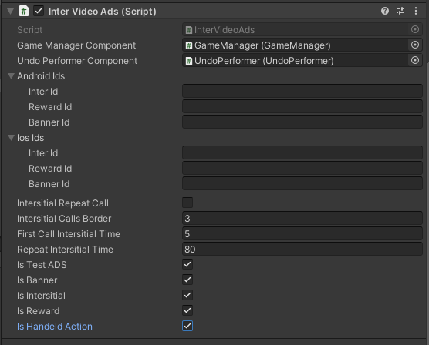
And GoogleMobileAdsSettings.asset
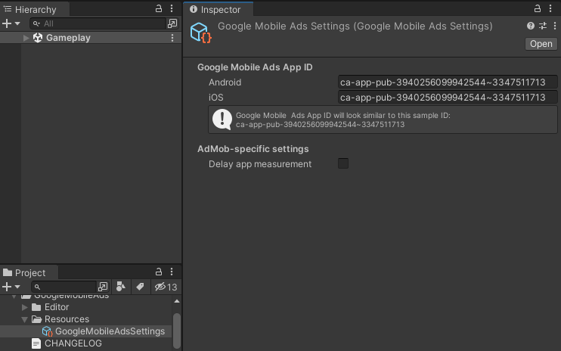

- For activating test ADS you should set IsTestADS variable to TRUE before play (like on screen). For deactivating test ADS you should set IsTestADS variable to FALSE before play.
Undo
Undo logic has option for counting available uses. When counter equals 0 for getting additional uses user should watch Rewarded video. More information in videos at asset page. 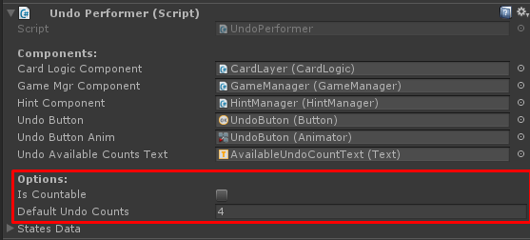
Last game option
You can enable/disable it at GameManager component.
Principle of work: User open new game session. When user close application the system save last game state(decks, cards, score, time, steps). When user open game again the system show popup:

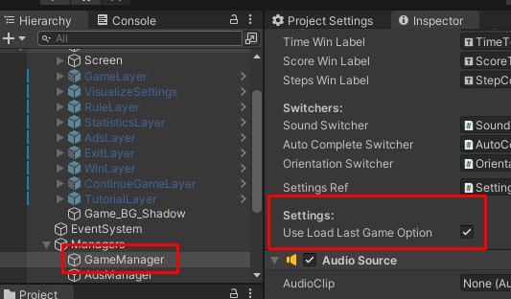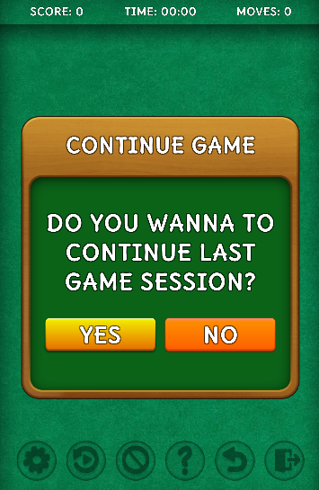
Hand orientation mode
Include two modes: Left-handed and Right-handed
You can enable/disable this feature in VisualizeSettings window.

Auto Complete
Include two modes: FullGameSession and OnlyWhenAllDecksClear.
FullGameSession mode appear auto complete button every time when user has available move during the game session
OnlyWhenAllDecksClear mode appear auto complete button only in the end of game when all cards is can drag by user just for win game.
You can enable/disable this feature in VisualizeSettings window.
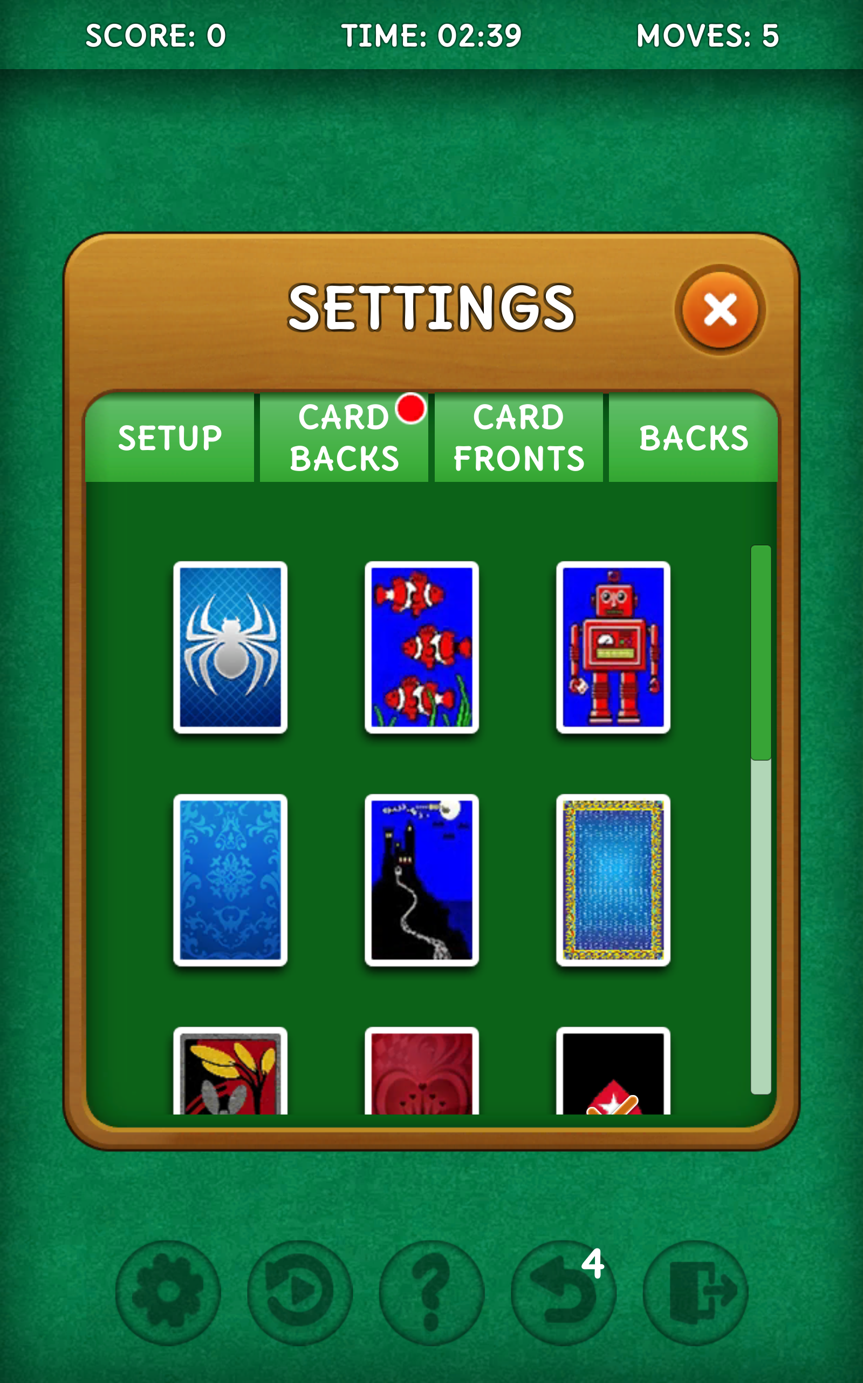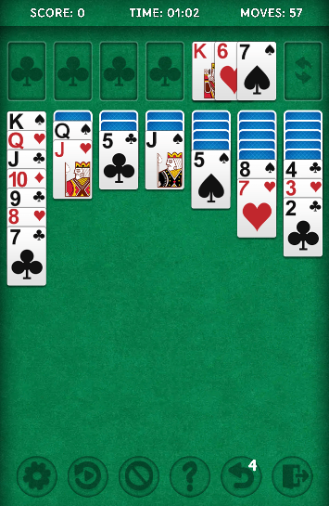

Draw rules

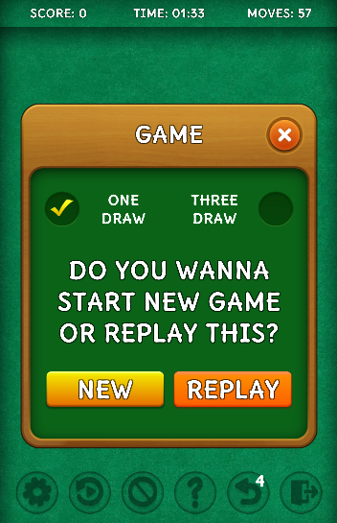
You can open game Window from this window and setup necessary rules by activating specific toggle and click New or Replay buttons to appy choose.

For other questions write me an email: support@selvassets.ltd.ua
Thank you in advance!

